**CASE STUDY ON EVALUATION OF COMPUTERS**

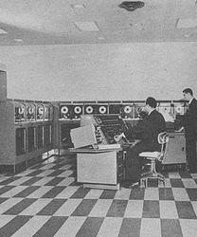

**INTRODUCTION:**

**Computers are such an integral part of our everyday life now most people take them and what they have added to life totally for granted.**The history of the computer goes back several decades however and there are five definable generations of computers .Each generation is defined by a significant technological development that changes fundamentally how computers operate – leading to more compact, less expensive, but more powerful, efficient and robust machines.

**1940 – 1956:  First Generation – Vacuum Tubes**

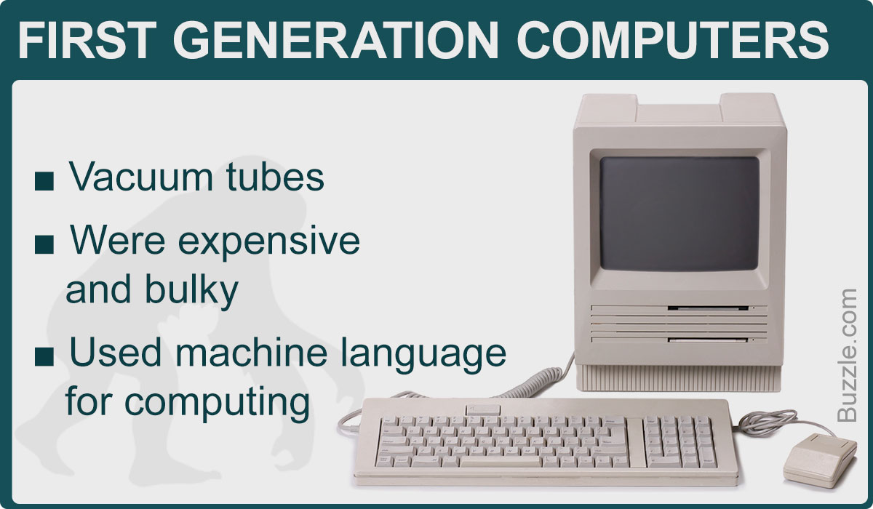

These early computers used vacuum tubes as circuitry and magnetic drums for memory. As a result they were enormous, literally taking up entire rooms and costing a fortune to run. These were inefficient materials which generated a lot of heat, sucked huge electricity and subsequently generated a lot of heat which caused ongoing breakdowns.

**FEATURES:**

* These first generation computers relied on ‘machine language’ (which is the most basic programming language that can be understood by computers).
* These computers were limited to solving one problem at a time. Input was based on punched cards and paper tape. Output came out on print-outs.
* The two notable machines of this era were the UNIVAC and ENIAC machines – the UNIVAC is the first every commercial computer which was purchased in 1951 by a business – the US Census Bureau.

**ADVANTAGES:**

1. Made use of vacuum tubes which are the only electronic component available during those days.
2. Use of vacuum tube technology made possible to make an electronic digital computer.
3. These computers could calculate in milliseconds.

**DISADVANTAGES:**

* Supported machine language only
* Very costly
* Generated a lot of heat
* Slow input and output devices
* Huge size
* Need of AC
* Non-portable
* Consumed a lot of electricity

**1956 – 1963: Second Generation – Transistors**

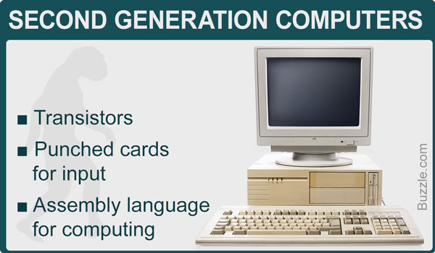

**FEATURES:**

* They were a big improvement over the vacuum tube, despite still subjecting computers to damaging levels of heat.
* However they were hugely superior to the vacuum tubes, making computers smaller, faster, cheaper and less heavy on electricity use.
* .The language evolved from cryptic binary language to symbolic (‘assembly’) languages. This meant programmers could create instructions in words. About the same time high level programming languages were being developed (early versions of COBOL and FORTRAN).
* Transistor-driven machines were the first computers to store instructions into their memories – moving from magnetic drum to magnetic core ‘technology’.

**ADVANTAGES:**

1. Smaller in size as compared to the first generation computer.
2. The second generation computers were more reliable.
3. Used less energy and were not heated as much as first generation computer.
4. Wider commercial use.
5. Better portability as compared to the first generation computers.
6. Better speed and could calculate data in microseconds.
7. Used faster peripherals like tape drives, magnetic disk etc.

**DISADVANTAGES:**

1. The cooling system was required.
2. Constant maintenance required.
3. Commercial production was difficult.
4. Only used for specific purposes.
5. Costly and not versatile.
6. Punch cards were used for input.

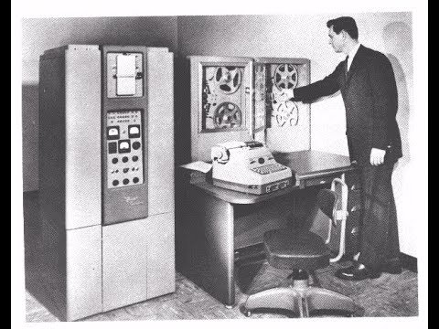

**1964 – 1971: Third Generation – Integrated Circuits**

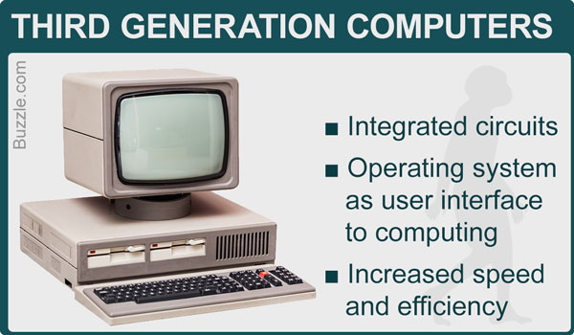

**FEATURES:**

By this phase, transistors were now being miniaturised and put on silicon chips (called semiconductors). This led to a massive increase in speed and efficiency of these machines.  These were the first computers where users interacted using keyboards and monitors which interfaced with an operating system, a significant leap up from the punch cards and printouts. This enabled these machines to run several applications at once using a central program which functioned to monitor memory.As a result of these advances which again made machines cheaper and smaller, a new mass market of users emerged during the ‘60s.

**ADVANTAGES:**

1. Smaller in size as compared to previous generations.
2. More reliable. Used less energy.
3. Produced less heat as compared to the previous two generations of computers.
4. Better speed and could calculate data in nanoseconds.
5. Used fan for head discharge to prevent damage.
6. Maintenance cost was low because hardware failure is rare.
7. Totally general purpose. Could be used for high-level language.
8. High storage capacity than the previous generation’s computer.
9. Versatile to an extent. Less expensive.
10. More accurate than previous. Used mouse and keyboard for input.

**DISADVANTAGES:**

1. Air conditioning was required.
2. The highly sophisticated technology required for the manufacturing of IC chips.

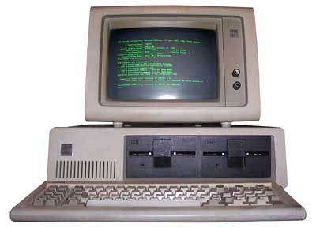

**1972 – 2010: Fourth Generation – Microprocessors**

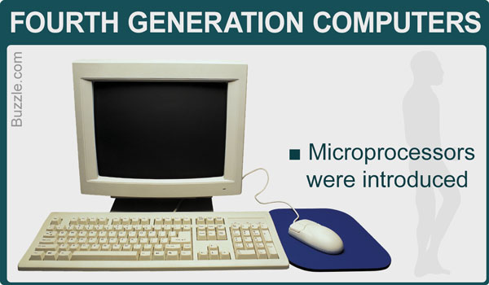

**FEATURES:**

1) The fourth generation computers have microprocessor-based systems. It uses VLSI (Very Large Scale Integrated) circuits.

2) They are the cheapest among all the computer generation.

3) The speed, accuracy and reliability of the computers were improved in fourth generation computers.

4) Many high-level languages were developed in the fourth generation such as COBOL, FORTRAN, BASIC, PASCAL and C language.

5) A Further refinement of input/output devices was developed.

6) Networking between the systems was developed in fourth generation computer.

**ADVANTAGES:**

* They were developed for totally general purpose use (general purpose computers).
* Smaller in size and much reliable than other generations of computer.
* The heat generation was negligible.
* No cooling system required in many cases of fourth generation computer.
* Portable and cheaper than the older versions.
* Fourth generations computer were much faster than the older generations.
* Graphics User Interface (GUI) technology was exploited to offer more comfort to users. PCs became more affordable and widespread during this period.
* Less repairement time and maintenance cost.
* They were developed for commercial production as well.
* All types of High-level languages can be used in this type of computers

**DISADVANTAGES:**

* The very advanced technology was required to fabricate to the ICs (Integrated Circuits).
* High quality and reliable system or technology can only make the ICs.
* Cooler is required (Fan)
* The latest technology is required for the manufacturing of Microprocessors.

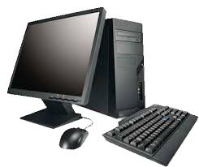

**2010-….. : Fifth Generation – Artificial Intelligence**

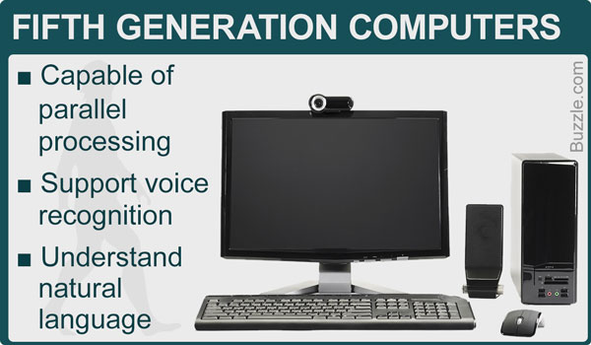

**FEATURES:**

1) The fifth generation computers will use super large scale integrated chips.  
2) They will have artificial intelligence.  
3) They will be able to recognize image and graphs.  
4) Fifth generation computer aims to be able to solve highly complex problem including decision making, logical reasoning.  
5) They will be able to use more than one CPU for faster processing speed.  
6) Fifth generation computers are intended to work with natural language.

**ADVANTAGES:**

These computers are much faster than other generation computers.  
» It is easier to repair these computers.  
» These computers are much smaller in size than other generation computers  
» They are portable and easy to handle.  
» Development of true artificial intelligence.  
» Advancement in Parallel Processing.  
» Advancement in Superconductor technology.

**DISADVANTAGES:**

They tend to be sophisticated and complex tools.  
» They can give more power to companies to watch what you are doing and even allow them to infect your computer.

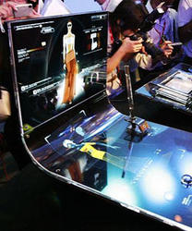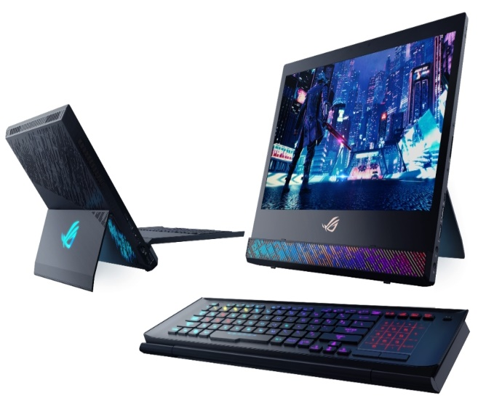

**CONCLUSION:**

After this case study on analysis of evolution of computers we conclude that the first generation of computers was based on Vacuum Tubes and took vast space. Second generation was based on Transistors and saved a lot of space and improved performance. Third generation was based on Integrated Circuits (IC) and furthered the development of efficient and faster computers. Fourth generation was based on Micro Processors and were very modern compared to predecessors.Fifth generation was based on Multiple Core processors and Artificial Intelligence like Alexa , Siri, Google Assistant, Cortana etc.And is still under further development phase.

**PC CONFIGURATION:**

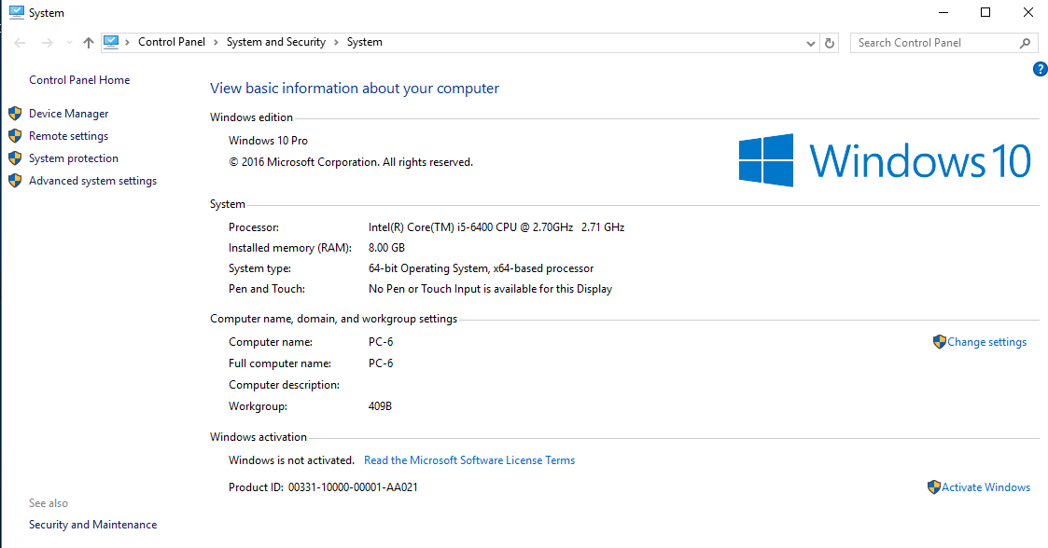

**CELL PHONE CONFIGURATION:**

**MODEL :** XIAOMI REDMI NOTE 4

**RAM:** 4GB

**ROM :** 64GB

EXPANDABLE MEMORY UPTO 128GB

**PROCESSOR:** QUALCOMM SNAPDRAGON 625

**PROCESSOR TYPE**: OCTA CORE

**PROCESSOR SPEED** : 2GHz

**GRAPHICS** : ADRENO 506

**SCREEN TYPE:** IPS LCD

**SCREEN SIZE**: 5.5 INCH

**SCREEN RESOLUTION**: 1920X1080 PIXELS

**REAR CAMERA**: 13MP

**FRONT CAMERA**: 5MP

**OS** : ANDROID 7.0 NOUGAT

**BATTERY CAPACITY** : 4100MAH

**SENSORS :** Fingerprint sensor, Accelerometer ,Gyroscope ,Proximity sensor ,Compass, Infrared sensor.

**COMMS:**

WLAN : WIFI 802.11 a/b/g/n, WiFi Direct

BLUETOOTH 4.1, GPS , GLONASS